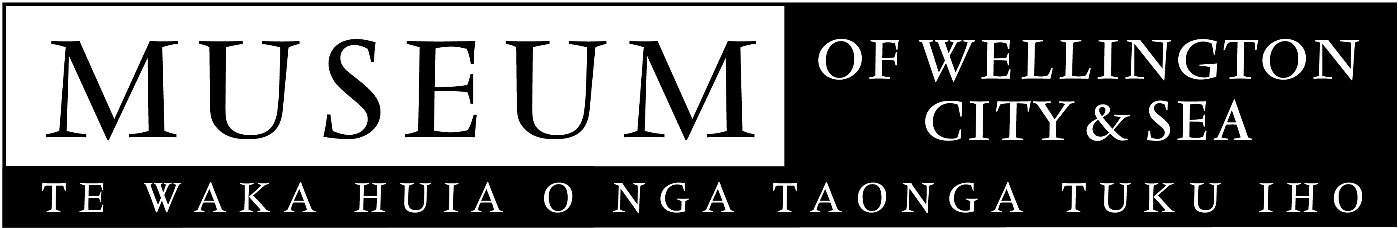
May 2006

MEDIA RELEASE

Two great events are happening at the Museum over the winter months. Wellingtonia, photographs by noted Wellington photographer, Julian Ward, and Wellingtonia LIVE, a festival of free events that takes the visitor from the controversy of the south coast development, to the pure entertainment of The Beat Girls.

Wellingtonia L I V E Festival (3 June to 30 July)

The Wellington public are being invited to be entertained at the Museum of Wellington City & Sea this winter with a free festival of over 70 events. Presented in association with Wellington Waterfront Limited, Wellingtonia LIVE runs from 3 June to 30 July. The Museum will have free activities taking place outside and inside the Museum, including Sunday Concerts, Maritime Mondays, Walks and Talks and after-hours Ghost Tours.

“It never ceases to amaze me how much diverse talent there is in Wellington” Elton Hayes, Public Programme Coordinator, says.
The festival kicks off with a special performance from one of Wellington's most celebrated musical groups, Rhombus, at 1pm, Saturday 3 June, closely followed Ali Harper & her Band of Boys, at 2.30pm.
The two month Wellingtonia LIVE festival closes with a gala auction at 3.30 pm on Sunday 30 July. Proceeds from the auction go toward the Museum’s proposed library room, ‘The Portal’. Tickets are only $5 and are available from the Museum Shop.
A full programme is available from the Museum on 04-472 8904 or on the website www.museumofwellington.co.nz

WELLINGTONIA – Photographs by Julian Ward (3 June to 30 July)
During the Wellingtonia LIVE festival the Museum’s exhibition space will be full of quirky images of Wellington. Wellingtonia, an exhibition of photographs by Julian Ward, provides a fitting setting for the Museum’s diverse festival and coincides with the launch of Julian’s new book by the same name.
“I have been watching and photographing Wellington for about thirty years, looking at its curiosities and quirky moments,” Julian Ward says. “The book and exhibition are a way to bring together a collection of work about a city I love.”
Wellingtonia is also published as an issue of Photoforum a society dedicated toward photography as a means of expression. Julian’s book and t-shirts with images from the exhibition are available from the Museum shop.

The Museum is open from 10am to 5pm daily and entry is free. Located on Queens Wharf, the City Circular bus takes you to the Museum’s door.

The Museum of Wellington City & Sea is managed by the Wellington Museums Trust with major funding from the Wellington City Council.

Photos available and photo opportunities arranged on request:
Wellingtonia – exhibition of photographs by Julian Ward.
The 72 events in the Wellingtonia LIVE festival.

For further information please contact
Kim Young
04-496 1947

kim.young@wmt.org.nz

