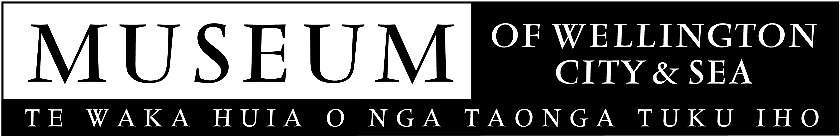
May 2006
MEDIA RELEASE

Poets Tell Tales About Wellington

A wall of poetry exploring tales of Wellington is being unveiled at the Museum of Wellington City & Sea.

The poetry by Masters students of The International Institute of Modern Letters is a creative response to the Museum’s Telling Tales exhibition.

“It has been great working with these students and they enthusiastically took on the challenge of creating these works”, Brett Mason, Acting Director of Museum of Wellington City & Sea, says.

The poets, novelists and short story writers were given a tour of the exhibition and an understanding of how the exhibition was set out and its major themes.

“These writers have taken public tales of Wellington and giving them a personal and creative twist.” Brett says.

The poetry wall is part of the Telling Tales exhibition which through 100 stories explores Wellington’s interaction with the 20th Century’s major developments and events.

"The MA students have enjoyed stepping into Wellington's immediate past, and into the community's history. If the quality of their work is anything to go by, the journey has been enormously stimulating." Bill Manhire, Director of The International Institute of Modern Letters, says

The International Institute of Modern Letters (IIML) is an international centre focusing on contemporary imaginative writing. Victoria University was chosen to be its New Zealand headquarters; it opened in March 2001. There are a number of co-centres at major universities in the USA.

The Museum of Wellington City & Sea is managed by the Wellington Museums Trust with major funding from the Wellington City Council.

For further information please contact
Kim Young
04-496 1947
Kim.young@wmt.org.nz

