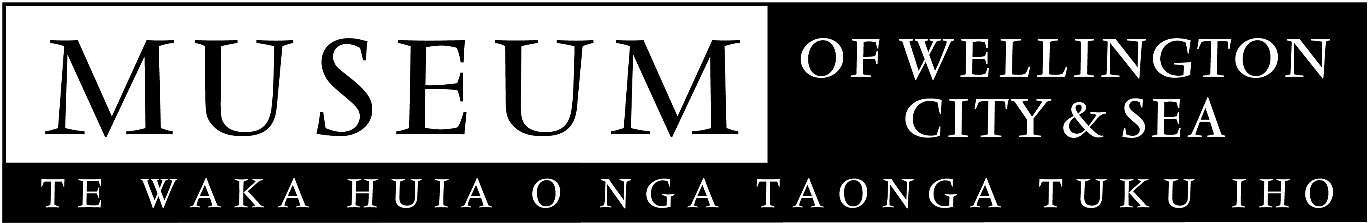

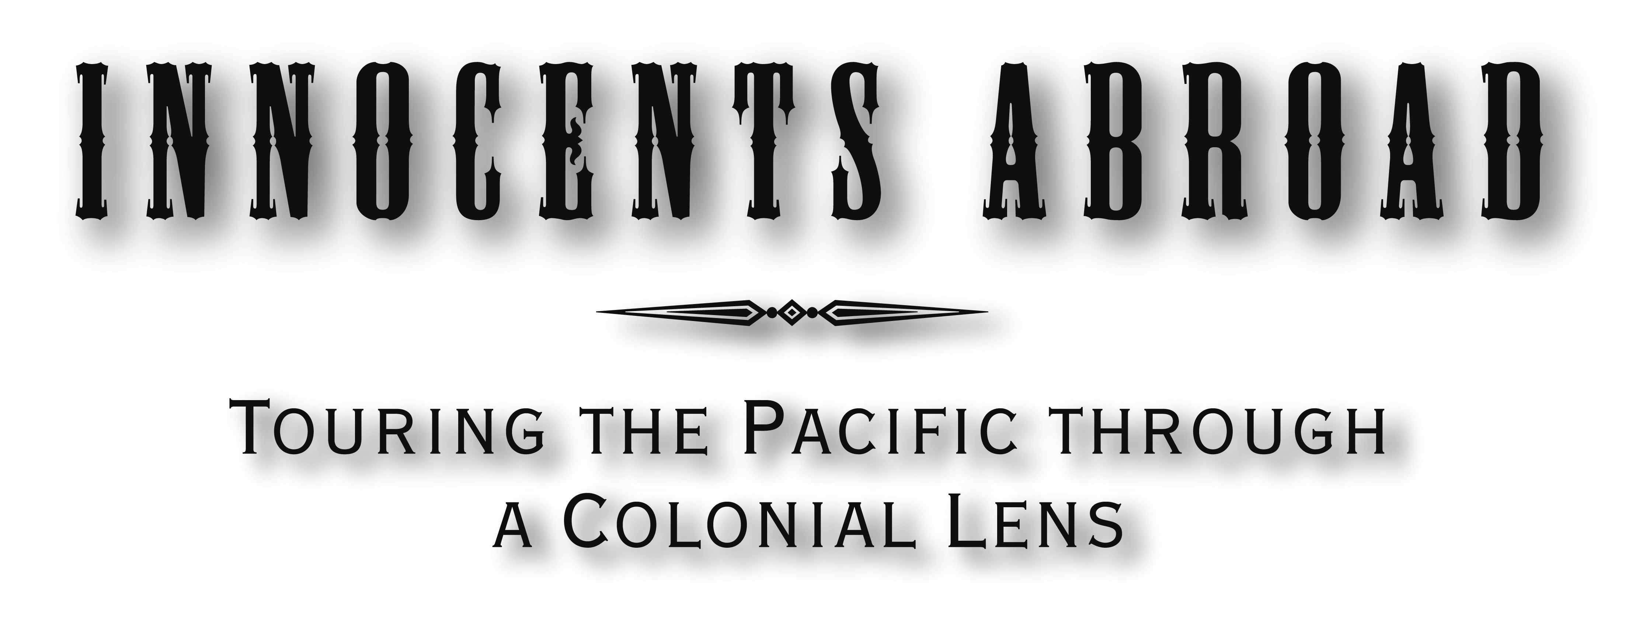
New Zealand International Festival of the Arts exhibition

Exhibition developed in partnership with Te Papa with the support of Imagelab.

Opens 23 February 2006

The Prime Minister, the Rt Hon Helen Clark, will officially open the exhibition Innocents Abroad at the Museum of Wellington City & Sea on the night of February 22. A night of entertainment includes Fire Dancers and the Tongan Congregational choir of the Wesley Church.

New Zealanders have been visiting the Pacific islands as a tourist destination for over 100 years. In June 1884, the Union Steamship Company ran the first tourist cruise into the islands from New Zealand, visiting Fiji, Samoa, American Samoa and Tonga. The photographer Alfred Burton of the Dunedin based firm the Burton Bros, was onboard the Wairarapa for the inaugural trip.

The Burton Brothers ran one of the biggest photographic companies in nineteenth-century New Zealand, and their photographs are recognised as having left an unparalleled record of New Zealand’s development and for capturing many aspects of Mäori and Polynesian culture at the time.

Paul Thompson, the Museum’s director says that Alfred’s photographs stand out from other Pacific photos of the time as they go beyond the usual postcard view to show the everyday activities of island peoples.

‘His photos are also intriguing as they capture the colonial view of the Pacific Islands in the early 1880s.’

Innocents Abroad comprises 74 images from Alfred Burton’s trip. The bulk of the photographs have been drawn from Te Papa’s Burton Bros collection, as well as a number of original albumen prints from Canterbury Museum and one from Alexander Turnbull Library and the exhibitions signature image drawn from the Museum’s own photography collection.

In congratulating the Museum on the joint initiative, Dr Seddon Bennington, Chief Executive of Te Papa, comments on the relationship

'Working closely with other museums is an important and enjoyable part of Te Papa's role, so we were delighted at the opportunity to collaborate with our nearest neighbour on an exhibition that draws on a significant aspect of Te Papa's photography collection.

The curator, Brett Mason of the Museum of Wellington City & Sea, has been assisted by Te Papa’s curatorial staff as well as drawing on expert writers from the Pacific islands. The writers are Larry Thomas, playwright and filmmaker of Fiji, Momoe von Reiche poet and artist of Samoa, US- based poet Dan Taulapapa McMullin writing on American Samoa and on Tonga the academic Dr ‘Okusitino Mahina with his daughter Te Papa’s Pacific curator Kolokesa Mahina.

The exhibition is to be presented as an installation rather than a typical gallery hang. The exhibition design is by Samoan-born architectural designer, historian and theorist, Albert Refiti, and a soundscape is being created by Plan 9 of Wellington, who have most recently worked on the TVNZ history series Frontier of Dreams. A catalogue has been published with essay’s by Brett Mason, maritime historian Dr Gavin McLean and New Zealand Samoan poet Tusiata Avia.

After its season at the Museum, Te Papa will tour the exhibition throughout New Zealand. Eight Regional museums and galleries will display the exhibition with the national tour running from May 2006 until early 2008.

Today New Zealanders visit the islands in greater numbers than ever before, more often than not they stay in tourist resorts and only rarely venturing outside the resort compounds to visit ‘iconic’ places of interest. For the Museum visitor they will experience an exhibition that goes beyond romantic exoticism to explore the realities of life in the South Pacific in 1884, the British, German and American colonial aspirations in the region at that time, and the contemporary Pacific view of this era of colonialism.

The Museum has received support from the Lion Foundation for the exhibition and is managed by the Wellington Museums Trust with major funding support from the Wellington City Council.

Public Programmes
In association with the Museum the NZ Film Archive is showing Pictures, the 1981 film on the life of the Burton brothers. Wednesday 1 March at 6.30pm in the NZ Film Archive’ Mediatheatre cnr Ghuznee & Taranaki Streets. Further public programmes are to be announced.

Images are available on request.

Museum of Wellington City & Sea
Queens Wharf
Open daily, 10am to 5pm, free entry

For further information please contact Brett Mason, ph 496 1947 or email brett.mason@wmt.org.nz

