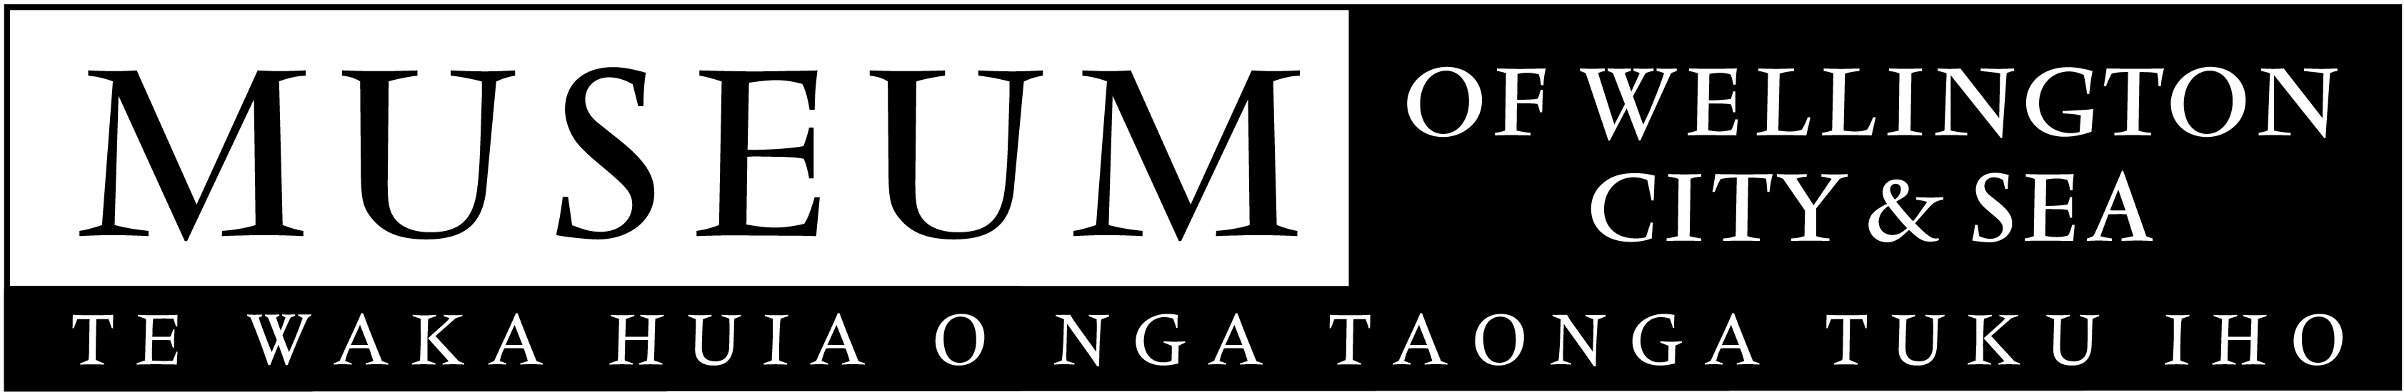
May 2006

MEDIA RELEASE

Headstone Unveiled For Reclusive Maritime Artist

Nearly 65 years after his death, Frank Barnes will finally receive a head stone for his unmarked grave in Taita cemetery.

Early this year the Museum of Wellington City & Sea held an exhibition of Frank Barnes’ works and used the opportunity to raise funds for a headstone.

A shepherd and his ships, with 70 paintings, was the most significant exhibition of maritime works by one artist ever shown in Wellington.

Painting many of his pictures from his hut, from which he could see ships entering and leaving the Wellington Heads, Frank Barnes generated a wealth of images that document the changes in New Zealand shipping during the early 20th century.

‘Very little is known about Frank Barnes’ life, even though he is one of New Zealand’s most prolific maritime artists to date,’ curator Laureen Sadlier says.

Said to be a former mariner, Barnes worked as a shepherd for the Riddiford family on Orongorongo Station near Wellington from about 1895 until just before his death in 1941. He lived like a hermit in a small hut (known as ‘Barney’s whare’), training dogs for the station and painting ship portraits to help pay for drinks on his rare trips into town.

Barnes’ paintings include a range of vessels from the Wellington pilot boat Toia to the Royal Navy cruiser HMS New Zealand, from coastal traders to passenger liners.

‘His paintings are significant because of his long career and his varied subjects, which show the changes in shipping through his portraits of both sail and steam-powered vessels,’ Laureen says.

‘He was a naïve artist with a real talent, and his early paintings contain an incredible amount of detail.’

A small ceremony to unveil the headstone will be held at Taita Cemetery, Naenae Road (opp. Glover Memorials) on Wednesday 10 May at 10.30am.

The Museum of Wellington City & Sea is managed by the Wellington Museums Trust with major funding from the Wellington City Council.

For further information please contact
Kim Young
Marketing Manager
04-496 1947
Kim.young@wmt.co.nz
(images of Frank’s painting are available on request)

