15 May 2008  MEDIA RELEASE | 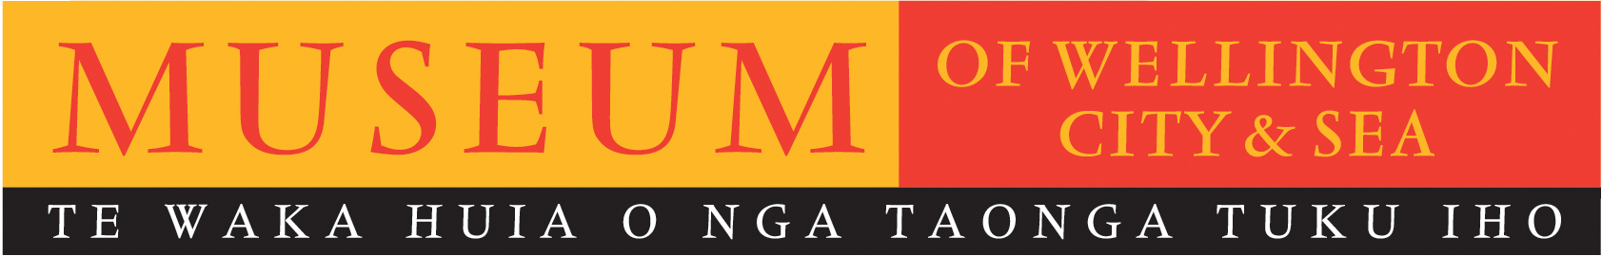

Contemporary Jewellers interpret Wellington’s history

Jewellery Students from Whitireia Community Polytechnic will present new, interpretive art works at the Museum of Wellington, as part Contemporary Translations in Jewellery – an art-based response to the Museum’s Telling tales exhibition, which chronicles selected events in Wellington’s 20th century history.

Contemporary Translations in Jewellery is the latest exhibition in the Museum's ongoing
Re-Telling Tales series, in which groups from different artistic disciplines are invited to present their interpretations of how the Museum presents Wellington’s history.

Brett Mason, Director of Museum of Wellington, says “The Museum should be a place where both history and current voices interact. In presenting new exhibitions, we must always allow room for the authority of the Museum to be questioned - which is why the Re-Telling Tales series is so important. Contemporary Translations in Jewellery is a significant exhibition in this series”.

Peter Deckers, Jewellery Lecturer & Media Coordinator at Whitireia notes “It takes a brave museum to offer its recorded history up for interpretation. Re-telling a tale in jewellery is not a simple act, however, by applying art-based methodologies we believe we have given the stories added meaning and depth.”
The seven jewellery students have each created their own contemporary interpretation of one specific event presented in Telling Tales. In doing so, some students have offered bold metaphoric statements, while others have made beautiful, detailed works of art.

Contemporary Translations in Jewellery offers visitors a further avenue to interpret and re-engage with the permanent exhibits on display in the Museum, as well as the opportunity to question their own beliefs on what jewellery could be.
Re-Telling Tales: Contemporary Translations in Jewellery
Museum of Wellington
15 May - mid-November, 2008
10am – 5pm
FREE ENTRY

For further information please contact publicist, Melanie Hamilton. Ph 04 496 1948,
or email melanie.hamilton@wmt.org.nz

Museum of Wellington, Queens Wharf. Open daily 10am to 5pm, FREE ENTRY www.museumofwellington.co.nz
The Museum of Wellington City & Sea is a Wellington Museums Trust facility and receives major funding from the Wellington City Council.

