27th March 2008  MEDIA RELEASE | 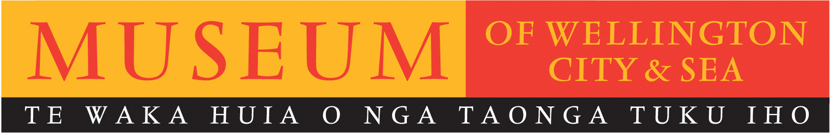

Museum commemorations for 40th anniversary of the sinking of The Wahine

On the morning of 10 April 1968, with 734 people on board, inter-island ferry The Wahine entered Wellington Harbour during a violent southerly storm and foundered on Barrett Reef.
Fifty-three people lost their lives giving it a place in history as one of New Zealand’s worst maritime tragedies.

To commemorate the 40th anniversary of this maritime disaster the Museum of Wellington is offering a significant programme of remembrance events, including an unveiling of the updated list of those who lost their lives. Events will take place throughout the day on Thursday 10 April.

Of note is a Commemorative Bus Trip along the Pencarrow Coast Road which will stop at sites where many of the survivors and victims washed ashore, offering people an opportunity to reflect and remember the events of the day. Guided commentary will be provided by two ex-crew members who survived the tragedy.

The Museum will also provide an Outdoor Display of emergency vehicles that were used to move survivors to medical help and transport victims away from the scene. The display will be situated under the sails on Queens Wharf, and vehicles will include one of the original NZ Army trucks used on the day of the disaster.

In addition to the programme of events detailed below the Museum of Wellington will also provide a private room for survivors, rescuers and their families.

Director of Museum of Wellington, Brett Mason comments, “In early 2007 the family of May Brightwell contacted the Museum to let us know that their mother had never been acknowledged as someone who had lost their life due to the Wahine disaster. After providing me with personal details of Mrs Brightwell’s death it was easy to see that this was an anomaly that should be corrected. The Museum’s list of those who lost their lives - either on the day or directly due to the disaster - now shows 53 names.

When the Museum was re-opened in 1999 it included the permanent exhibition The Wahine Disaster Gallery. Here we tell the story of the 10th of April 1968 with personal memorabilia, salvaged Wahine remnants, including its bell and a beautiful mural from its walls, as well as a moving and thoughtful film by Gaylene Preston. Through this gallery the Museum is seen by many as a permanent place of remembrance for those who lost their lives, were rescued or were rescuers, while for others it lets them find out more of that fateful day 40 years ago”.

Regarding media interviews - Museum Publicist Melanie Hamilton and Marketing Manager Kim Young will be available to assist all media with enquiries and interviews. If required, private rooms can be arranged for interviews. The best time for this is between 12.30pm – 1.15pm. Advance notice would be appreciated, so we can forewarn people and assist as much as possible.

MUSEUM OF WELLINGTON’S wahine 40th anniversary commemoration programme:

- 9.45am: Private wreath-laying ceremony and a prayer led by Dean Frank Nelson. Members of the public are also welcome to lay wreaths in the Museum’s Wahine Disaster Gallery throughout the day

- 10:00am: Unveiling of updated list of those who lost their lives

- 12.30pm: Contemplative music performed by Vector Wellington Orchestra String Quartet and Nota Bene Choir, including Pachelbel’s Canon (duration 45 min)

- 1.30pm: Commemorative bus trip along the Pencarrow Coast Road with guided commentary from ex-crew survivors (duration 3.5 hours)

- 2.00, 3.00 & 4.00pm: Film screening of newly released documentary The Wahine Disaster by Sharon Barbour (duration 45 min)

- 3.30pm: Talk on Wahine Weather by Philip Dickson, cartographer and meteorologist
(duration 30 min)

- 6.30 & 8.30 pm: Toi Whakaari: New Zealand Drama School's performance of Pakiwaitara (duration 1 hour). This devised promenade performance tells the stories housed within the Museum of Wellington, with a segment of the show focussing on The Wahine disaster.

Wahine 40th Anniversary Commemorations
Museum of Wellington
Thursday 10 April
10am – 5pm
Bus trip: $30 per person. Bookings: 04 472 8904
Pakiwaitara: $15/$10. Bookings: 04 381 9253
All other events FREE

For further information please contact publicist, Melanie Hamilton. Ph 04 496 1948,
or email melanie.hamilton@wmt.org.nz

Museum of Wellington, Queens Wharf. Open daily 10am to 5pm, FREE ENTRY www.museumofwellington.co.nz
The Museum of Wellington City & Sea is a Wellington Museums Trust facility and receives major funding from the Wellington City Council.

