3 July 2008  MEDIA RELEASE | 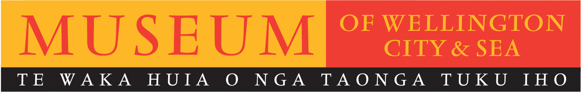

The TREATY 2 U new look tour begins at Museum of Wellington

From July through to October the Museum of Wellington will be home to TREATY 2 U, a touring exhibition that tells the stories of our nation’s founding document, the Treaty of Waitangi.

TREATY 2 U explores the events that led up to the Treaty, from first contact between Mäori and Pakeha, to the lengthy debate that occurred the night before signing. The exhibition explains what is written in the documents and the crucial differences between the Mäori and English versions. Visitors to the exhibition will be able to view replicas of the original nine Treaty documents and follow the documents’ journeys during1840 as more signatures were sought.

TREATY 2 U was originally a mobile exhibition that toured New Zealand from 2006 to early 2008. People may remember the specially constructed truck that housed it. To give the exhibition a longer life and allow for a deeper visitor experience the exhibition will be housed inside Museums around the country, offering the opportunity for local input. At the Museum of Wellington visitors will learn about the Wellington area claims and uncover ‘the price of Wellington’.

Members of the public will be able to comment on issues raised by the exhibition, leaving their thoughts on a post-it board which will remain up for the duration of the exhibition. A quiet reading area will also be provided.

‘The two national tours and tour of Auckland secondary schools 2006 – 2008 have shown us that New Zealanders are interested in knowing more about their history,’ said Dr Claudia Orange, Te Papa’s History & Pacific Cultures Director.

‘TREATY 2 U allows people of all ages to engage with the stories of the past and better understand the significant place of the Treaty of Waitangi within it. We are excited about this next step for the exhibition and sincerely hope that it allows for deeper exploration and repeat visitation for those who haven’t had the opportunity to linger in the exhibition previously,’ Dr Orange said.

TREATY 2 U aims to show that despite controversy over the years, the Treaty of Waitangi continues to help New Zealanders understand the past, make sense of the present, and build for the future. The Museum of Wellington is pleased to offer people the opportunity to experience this significant exhibition.

TREATY 2 U Touring Exhibition created by the Museum of New Zealand Te Papa Tongarewa, Archives New Zealand Te Rua Mahara o Te Käwanatanga, and the National Library of New Zealand Te Puna Mätauranga o Aotearoa.
Further information can be found online at: www.treaty2u.govt.nz

TREATY 2 U
Saturday 12 July to Sunday 12 October

Museum of Wellington
Queens Wharf
Phone 04 472 8904
www.musemofwellington.co.nz

Open Daily, 10am – 5pm

FREE ENTRY

For further information please contact Museum of Wellington publicist, Melanie Hamilton.
Phone: 04 496 1948. Email: melanie.hamilton@wmt.org.nz

Museum of Wellington, Queens Wharf. Open daily 10am to 5pm, FREE ENTRY www.museumofwellington.co.nz

The Museum of Wellington City & Sea is a Wellington Museums Trust facility and receives major funding from the Wellington City Council.

END

