05 May 2008  MEDIA RELEASE | 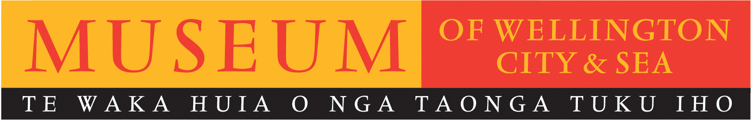

Personal favourites on display at Museum of Wellington

Fifteen volunteers from the Museum of Wellington will present their favourite objects from the Museum’s Collection Store for display in Our Choice – a volunteer’s perspective of a Museum’s Collection, Saturday 17 and Sunday 18 May as part of International Museums Day.

Collection Manager, Dean Miller, says that “Publicly acknowledging the dedicated work of the Museum’s volunteers and allowing them to display whatever object they deem most important and interesting from the collection is the perfect way to mark International Museums Day”.

The Museum’s collection numbers over 65,000 items and approximately only 5% are on public display at any one time. Our Choice offers an unusual snapshot of the collection while demonstrating the varied and interesting work the volunteers take part in.

Our Choice highlights personal links volunteers have to many of the objects in the Museum’s collection. Pen Brown, for instance, has chosen to display a lifebuoy from the Corinthic - the ship on which his grandparents and father migrated to New Zealand on - while Hilda McDonnel, who loves the stylish crockery used on the passenger ships of the 1930’s, will display a set of fine china used on the Awatea.

International Museums Day has been celebrated all over the world since 1977, to celebrate that museums are an important means of cultural exchange, co-operation and peace among peoples. Our Choice offers visitors a unique chance to see a range of items from the Museum’s collection (many of which have never been on public display), all chosen by a group of committed volunteers. For the duration of the exhibition volunteers will be present to talk informally to the public about their chosen item and why they treasure it so much.

Our Choice – a volunteer’s perspective of a Museum Collection
Museum of Wellington
Saturday 17 and Sunday 18 May
10am – 5pm
FREE ENTRY

For further information please contact publicist, Melanie Hamilton. Ph 04 496 1948,
or email melanie.hamilton@wmt.org.nz

Museum of Wellington, Queens Wharf. Open daily 10am to 5pm, FREE ENTRY www.museumofwellington.co.nz
The Museum of Wellington City & Sea is a Wellington Museums Trust facility and receives major funding from the Wellington City Council.

