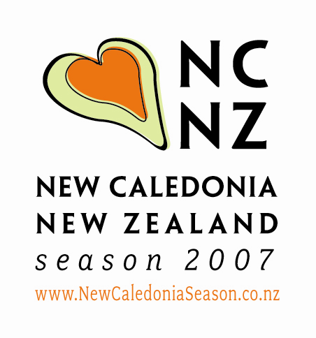

MEDIA RELEASE

FOR IMMEDIATE RELEASE
1 August 2007
Exhibitions reveal a rich cultural and historical side to New Caledonia close to New Zealand’s heart
Two exhibitions, War in Paradise and KANAKart – Ancestral Body, opening simultaneously in Wellington in August, prove that beyond the picture-perfect tropical island image of New Caledonia, lies a country with a rich history and vibrant contemporary culture. And as these exhibitions reveal, there is a familiarity about it that New Zealanders can identify with.
During World War II the Third New Zealand Division was stationed in New Caledonia. War in Paradise is the story of the troops’ time there, told through an installation of official photographs and extracts from the Division’s unofficial history series, published at the end of the war. Director of Museum of Wellington City & Sea and Curator of War in Paradise, Brett Mason says “The exhibition explores the soldiers’ experiences and notions of the place they were in, how they related to the local people – Kanak, French, Indonesian and Vietnamese – and how they coped with living in ‘the Paris of the Pacific’ while preparing to confront the Japanese.”
Alongside the historic images is a fresh look at New Caledonia and the New Zealand War Cemetery and Memorial in Bourail through an installation of recent photographs by respected New Zealand photographer Paul Thompson.
Thompson says he was interested in going to a tropical island and creating images that were not of the clichéd (colourful) ‘tourist picture’ genre. “This was because I had decided to shoot in colour, to provide a contrast with the black and white images from the war years and to clearly establish a sense of different historical periods. The approach was also one that was metaphorical rather than documentary as there were few visible remnants left of the New Zealand presence.”
Installation designer David Waller has combined the old and new imagery to create a revelatory environment, a unique view of life in a Pacific country during a time of war. Complementing this, a soundscape commissioned from Plan 9 recreates the popular New Zealand, American and French music from the period and blends it with Kaneka beats and rhythms.
KANAKart – Ancestral Body is a groundbreaking exhibition linking traditional Kanak art and culture to contemporary expressions of Kanak art. Vibrant, dynamic and diverse traditional art works, including dramatic ceremonial masks and sacred objects of great significance from Musée de Nouvelle-Calédonie, provide a rare insight into Kanak culture.
Pataka Director and co-curator of KANAKart – Ancestral Body, Helen Kedgley, says that some works are startling, such as mourners’ masks with human hair, while others are iconic, like the hut architrave or roof-top arrow from Tiouandé. “Contemporary Kanak sculpture and paintings from the collection of the Tjibaou Cultural Centre’s Contemporary Kanak and Pacific Art Repository in New Caledonia are exhibited alongside the heritage items that have fuelled their imagination and shaped their identity, demonstrating the continuity of Kanak culture and the indescribable connection to ‘the ancestor’ in the creative process of the artist.”
Gilbert Bladinières, curator at the Tjibaou Cultural Centre in Noumea and co-curator of KANAKart – Ancestral Body says “We didn’t arrive at the theme of ‘Ancestral body’ by accident. The figure of the ancestor and its symbolic representations are omnipresent in Kanak art. Whether the vehicle is a ceremonial axe, a means of currency or a sculpture, all traditional artefacts refer to the ancestor, to its body, its spirit, its mystic power, its mana”.
“And this is still the case today. Although the approaches, techniques and materials of contemporary Kanak artists have evolved, they continue to proclaim this connection. And although this link to the past, this identity, is essential to their creations, it has never been an obstacle or hindered their work. Rather, it is the only means of progressing, inventing and finding a place for the artist in a society in a state of perpetual motion.”
Kedgley adds, “Kanak artwork remains the mediator between the real and invisible worlds and maintains an ongoing dialogue between past and present.”
The exhibiting artists in KANAKart – Ancestral Body are: Paula Boi, Yvette Bouquet, Dick Bone, Marc Deha, Lacheret Dioposoi, Yolande Moto, Micheline Néporon, André Wassaumié Passa, Jean-Jacques Poiwi, Joseph Kenal Poukiou, Steeve Thomo, Narcisse Wahnyo Teimbouec, Maryline Thydjepach, Bob Upigit, Ito Waia.
Artists Paul Boi and Jean-Jacques Poiwi will be in New Zealand for the opening of KANAKart – Ancestral Body. Paula is a pioneer, one of the first female artists to take a resolutely contemporary path, along with Micheline Néporon, Denise Tiavouane and Yvette Bouquet. A large part of her carefully considered and often daring work deals with traditional symbols and their reformulation. Jean-Jacques’ work is also very precise, very heartfelt. He works wood and stone with equal enthusiasm, and with great concern for precision and achieving intellectual outcomes. His strength lies in the demands he makes on himself.
Bladinières says “All of the works that feature in KANAKart – Ancestral Body are particularly meaningful to us. If they have the same effect on you, you will leave the exhibition transformed.”
WAR IN PARADISE
Opening Saturday 25 August
Museum of Wellington City & Sea, Queens Wharf, Wellington (open daily, 10:00am to 5:00pm, free entry)

KANAKart – Ancestral Body
Traditional and Contemporary Indigenous Art from New Caledonia
Opening Sunday 26 August
Pataka – Porirua Museum of Arts and Cultures (open Mon-Sat, 10:00am to 4:30pm, Sun 11:00am to 4:30pm

War in Paradise and KANAKart – Ancestral Body are part of the New Caledonia New Zealand Season 2007, proudly supported by the Government and Provinces of New Caledonia, and France through the Fonds Pacifique. Additional support is provided by the French Embassy.
War in Paradise has been developed in partnership with Association Passé de Bourail, Musée de Bourail and with assistance from Archives New Zealand/Te Rua Mahara o te Kawanatanga.
KANAKart – Ancestral Body has been developed in partnership with Musée de la Nouvelle-Calédonie, ADCK – Tjibaou Cultural Centre and Pataka – Porirua Museum of Arts and Cultures.

ENDS

Media enquiries: Caroline Nelson, Paradise PR Ltd, 021 244 1299,
caroline.nelson@paradise.net.nz

