1 August 2008  MEDIA RELEASE | 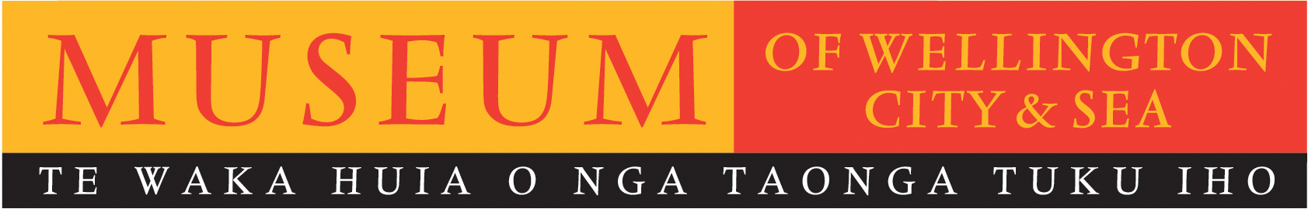

Literary aficionados get chance to delve further into the 2008
Montana New Zealand Book Awards

The Museum of Wellington is pleased to offer the public a free opportunity to hear more from the judges and finalists of the 2008 Montana New Zealand Book Awards at a lively literary event, Thursday 7 August at 7.30pm.

In the spirit of frank discussion Lynn Freeman and Tim Corballis will discuss the busy six month process of judging this year’s competition. Joining them will be three of the finalists and winners: Mary McCallum, Gregory O’Brien and Johanna Aitchison. Each author will give readings from their work and discuss the meaning of the awards to them as writers, and then all panellists will participate in a discussion about the issues and their experiences of the awards. The floor will then be opened for audience members to both contribute and hear more about issues raised throughout the evening.

Museum of Wellington director Brett Mason says “We are excited to offer the public this opportunity to delve deeper into the judging process of one of New Zealand’s most prestigious literary awards and robustly engage with some of New Zealand’s leading authors”.

The Montana New Zealand Book Awards are New Zealand's premier awards for contemporary writing, recognising excellence in books published annually in New Zealand. Mary McCallum won the Readers' Choice Award and NZSA Hubert Church Best First Book Award for Fiction for her novel The Blue, and was also a finalist for the Ficton Award. Gregory O'Brien won the Reference & Anthology Award for A Nest of Singing Birds: 100 years of the New Zealand School Journal and was also a finalist in the Illustrative category for Aberhart with Laurence Aberhart and Justin Paton. Johanna Aitchison was a finalist in the Poetry category with A Long Girl Ago.

This panel of award-winning writers and judges will offer extensive expertise across a wide range of literary genres, ensuring an insightful and expansive panel conversation on New Zealand writing at the Museum of Wellington.

Literary Excellence: Panel discussion on 2008 Montana New Zealand Book Awards
Museum of Wellington
Thursday 7 August, 7:30pm – 9:00pm
With judges Lynn Freeman and Tim Corballis, award winners Mary McCallum and Gregory O’Brien and finalist Johanna Aitchison.
FREE entry.

For further information please contact publicist, Melanie Hamilton. Ph 04 496 1948,
or email melanie.hamilton@wmt.org.nz

Museum of Wellington, Queens Wharf. Open daily 10am to 5pm, FREE ENTRY www.museumofwellington.co.nz
The Museum of Wellington City & Sea is a Wellington Museums Trust facility and receives major funding from the Wellington City Council.

