04 July 2008  MEDIA RELEASE | 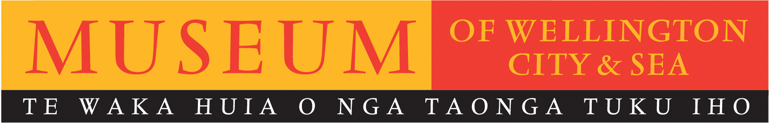

Memory explored by two generations at Museum of Wellington

The Museum of Wellington presents the world premiere of Memory – an intangible map, a live theatrical performance exploring the nature of memory and the delicate ties that bind generations, opening Sunday 27 July.

Facilitated by Voice Arts Trust, Memory - an intangible map looks at the unique relationship formed between East Eight, a group of young women from Wellington East Girls’ College, and a group of elderly women in hospital and dementia care at Village at the Park. Film and audio give insight into the lives of the elderly women, while on stage the young women share their explorations of memory and how this cross generational project has affected them. The film and live performance respond to one another, at times merging into one, giving the elderly women a clear stage presence, even though they are not performing in person.

Director of Museum of Wellington Brett Mason says ‘We are excited to work with Voice Arts on this project as it explores storytelling in a way not normally seen in museums. In May of this year we worked with Toi Whakaari: NZ Drama School where they devised new theatrical works, using stories from the Museum. With Memory – an intangible map Voice Arts takes a new approach and brings in stories from our community, using the Museum as their setting’.

Memory - an intangible map is designed for an intimate audience of just thirty-two people. While the stories within it are personal, the themes of memory, aging, generational divide and influence are universal.

Voice Arts Trust employs the art of performance to give voice to those individuals and groups within our community that are isolated or marginalised. Projects focus on the creation of original theatre, unique to each group, devised and performed by the participants. For Memory – an intangible map two disparate groups of women were brought together. The generational divide was gapping however, over time a genuine connection and collaboration was created. This process is documented at East Eight’s blog: http://intangiblememory.blogspot.com/
Memory – an intangible map celebrates both Wellington and New Zealand’s history, the importance of our personal stories and memories, and our shared sense of place.

"People are books...all of us...I'm 95 and it's just so important...these times....when we can talk with young people...and they can talk to us...we have so much to learn from each other..."
Oinah Mary MacPherson.
Memory – an intangible map
Museum of Wellington, Queens Wharf

Directed by: Heather Timms and Nicola Pauling
Production Design by: Caitlin Le Harivel
Film and Audio Design by: Sasha Mohelnitzky
Performed by: East Eight, drama students from Wellington East Girls’ College, and women from Village at the Park.
A collaboration between Voice Arts Trust and Museum of Wellington.

Dates: Sunday 27 July, Saturday 2, Sunday 3, Saturday 9 & Sunday 10 August.
Times: Each performance at 1pm.
FREE ENTRY. Booking is advised, as audience limited to 32 people. Phone 04 472 8904.

IMAGE CREDIT: Jasmine Williams (left, from East Eight) and Dawn Amaru (right, from Village at the Park).

For further information please contact publicist, Melanie Hamilton. Ph 04 496 1948,
or email melanie.hamilton@wmt.org.nz

Museum of Wellington, Queens Wharf. Open daily 10am to 5pm, FREE ENTRY www.museumofwellington.co.nz

The Museum of Wellington City & Sea is a Wellington Museums Trust facility and receives major funding from the Wellington City Council.

