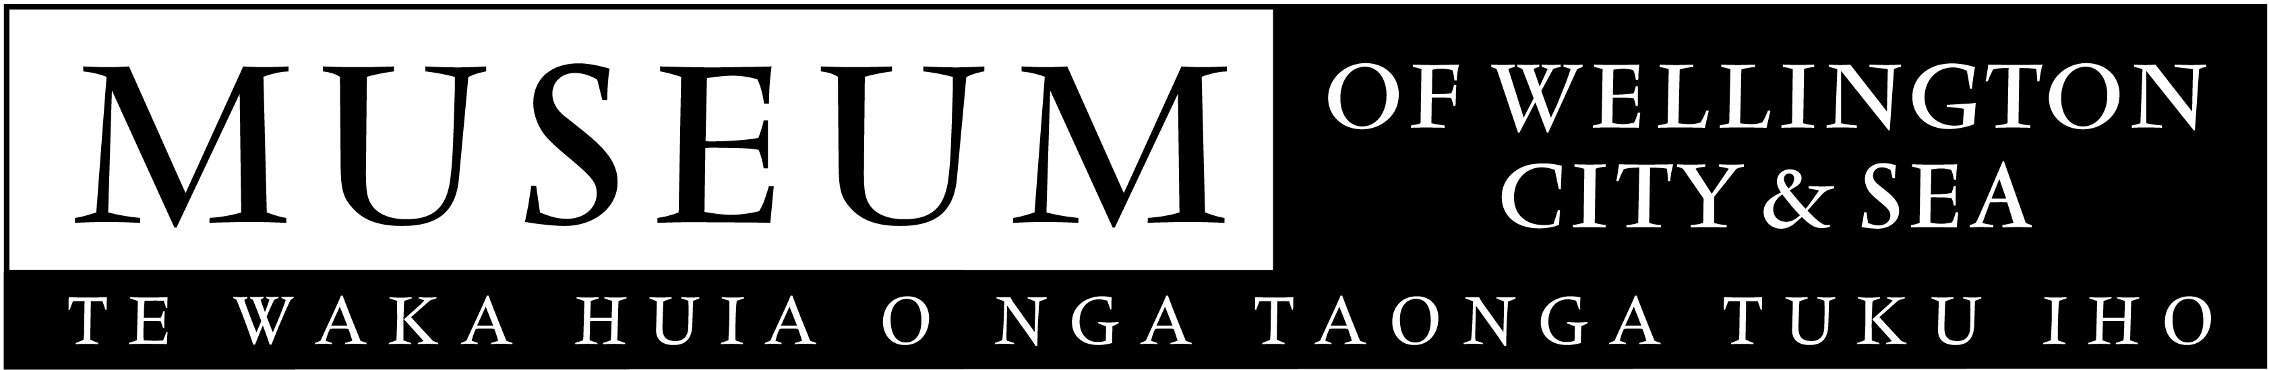
October 2007
MEDIA RELEASE

WelTec students tell tall tales

During the excavation of Wellington’s inner-city bypass site, a number of unexpected and unusual objects were uncovered by local enthusiasts – or were they? The Archaeology Department at Wellington Institute of Technology (WelTec) reveal eleven of these astonishing stories in Found Beneath the Bypass, a new exhibition presented by the Museum of Wellington City & Sea.

“We are thrilled to present such an eclectic mix of objects at the Museum. They in effect completely re-write history”, says Museum Director, Brett Mason.

Pictured, is a tobacco tin discovered by a local electrician, which might bring to an end a mystery that has its origins in France. The tin contains handwritten letters that might have been sent to New Zealand in 1914 from France during World War 1. Or are they props made by Tony Boyd of Wellington’s Custom Props?

One other curiosity is a small voodoo doll that may have been owned by Wellington’s transsexual queen of nightlife, Carmen Rupe, and then there is the partial manuscript that Katherine Mansfield could have dropped on her way home from studying at Wellington Technical College, around 1908. The manuscript suggests that her writing had a more ribald twist than has been previously thought.

Found Beneath the Bypass is an arts-based response from WelTec Visual Art students to one of the Museum of Wellington City & Sea’s most popular exhibitions Telling Tales, which explores Wellington’s interaction with the 20th Century’s major developments and events. Found Beneath the Bypass cheekily responds to this and gives Wellingtonians a further reason to celebrate the uniqueness of their city.

For further information on Found Beneath the Bypass please contact publicist, Melanie Hamilton. Ph 496 1948, email melanie.hamilton@wmt.org.nz

Found Beneath the Bypass, Opens 26 October, 2007
Museum of Wellington City & Sea, Queens Wharf
Open daily, 10am to 5pm. FREE ENTRY.

The Museum of Wellington City & Sea is managed by the Wellington Museums Trust with major funding from the Wellington City Council.

