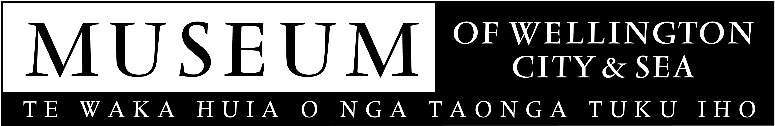

1913 Strike - War on the Wharves exhibition
(Opens 22 August 2006)

A dramatic new exhibition describes the progress of the violent 1913 strike that began on Wellington’s wharves and attracted world attention because of its scale and intensity.

The 1913 Strike - War on the Wharves exhibition at the Museum of Wellington City & Sea coincides with the recently published book ‘Revolution – the 1913 Great Strike in New Zealand’. At the launch of the book the Prime Minister, Helen Clark, referred to this strike as one of the most influential moments in New Zealand’s history.

During the strike militant workers took over the most vulnerable and vital link in the country’s economy. At its peak every major port in the country was shut down and each day saw armed conflict on Wellingtons street.

‘The Bond Store building that houses the Museum of Wellington City & Sea was in the centre of the action and is a fitting venue to recreate the feeling of those incredible days in late 1913’ says Museum Director, Brett Mason.

‘The gates to Queens Wharf were a physical & symbolic gateway. They were the access to the wharves and the country’s trade and livelihood. When the gates were shut, the wharves were shut down, and the country came to a standstill.’

Award winning Exhibition Designer, David Waller has designed a series of installations to capture the dramatic nature of the event.

‘The exhibition is designed as a thematic journey using text and life-sized images. You can get right up close to people’s faces and read their personalities’.

Curator Mark Derby became interested in the 1913 Strike through his involvement with Trade Union History Project and was intrigued that so little was known about this significant event.

‘Despite the intensity and consequences of this event it is an under explored part of New Zealand history. The exhibition includes some material that I don't think has appeared in public before. There's a letter proving that the police supplied guns to the volunteer 'special constables', although the police strongly denied this at the time’.

‘I'm sure there's a lot more information about the strike out in the community, like letters photos, diaries and stories from people who were living in Wellington in 1913. I'd be pleased if the exhibition had the effect of unearthing some of that precious historical material’, says Derby.

The exhibition was opened by Deputy Mayor, Alick Shaw. Setting the scene at the opening were ‘Massey’s Cossacks’ on horseback, a 1913 paper boy, and union singer.

Today Wellingtonians enjoy the leisurely atmosphere of the waterfront, unaware that it was once the scene of violence on a scale that is the closest to civil war that New Zealand has seen.

The Museum is managed by the Wellington Museums Trust
with major funding support from the Wellington City Council.

Public Programmes
A series of ‘Talks from the soap box’ is scheduled to coincide with the exhibition, covering topics from the involvement of the military, NZ Police and ‘Massey’s Cossacks’, to seafarers & unionism. Wellington Repertory Theatre performances of The Importance of Being Earnest will set the social tone for 1913.

Images are available on request.
Museum of Wellington City & Sea
Queens Wharf
Open daily, 10am to 5pm, free entry
For further information please contact Kim Young, ph 496 1947 or email kim.young@wmt.org.nz

